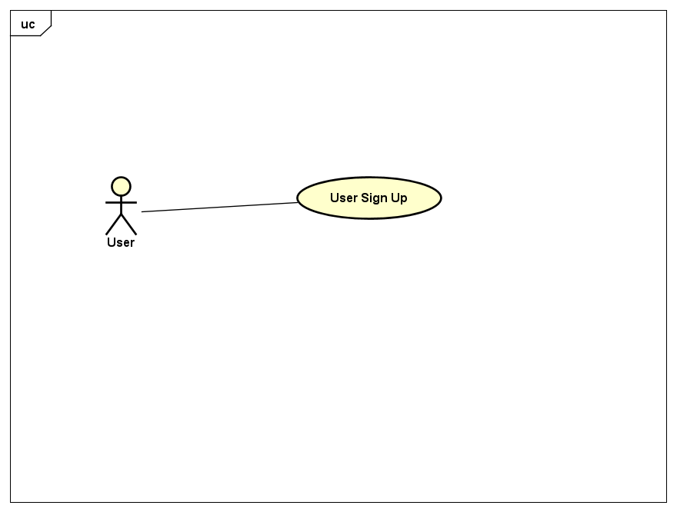

- Use Case Basic Information
Use case name: User Sign up
Actor: User
Description: User tries to register by providing name, first and last, username, email and password. The system saves this to its database and grants user access.
Triggers: A user needs to signup
Type: Temporal
Preconditions:
- The user must provide personal information

- Normal Course
- User sends request to sign up.
- System displays columns first name, last name, username, email, and password to be filled.
- System checks if fields are completed.
- System grants user access.

- Exceptions
E1.) Field are incorrectly filled
System displays incorrect first name, last name.
System throws exception (username cannot contain characters)
System throws exception (email in wrong format)
System throws exception (password too weak).

